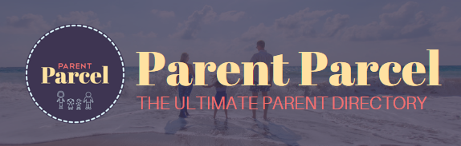
PARENT PARCEL REVIEW
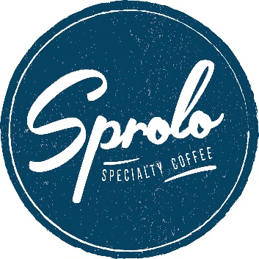
Business Name: Sprolo
Review: 9/10
Offer: Two for One Hot Drinks
Category: Kid Friendly Eats
Address: 138 Canning Hwy, South Perth WA 6151
Pros: indoors, kids area, great coffee
Cons: very popular = busy at times

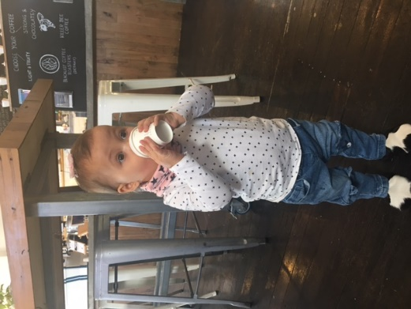
Sprolo is one of my favourite local cafes. With a modern almost hipster café with all the essentials including great food and even better coffee. It is a must to visit for me though as they really cater for kids.
Sprolo has a kid’s activity area where there are loads of toys, a chalk board and plenty of books to take back to your table if need be. I have been there many times with my daughter Frankii and her friends. When she is not playing with in the kid’s area she is up in a highchair enjoying her baby chino.
Love Aisha xo
Director Parent Parcel
